1. <https://www.youtube.com/watch?v=Of4HFbsPKqk&list=PLEocw3gLFc8XRaRBZkhBEZ_R3tmvfkWZz&index=2>
2. 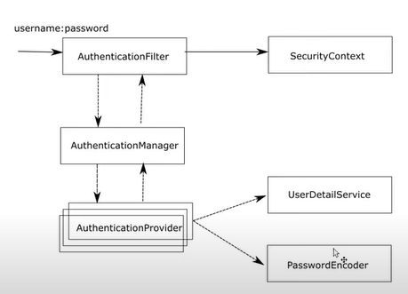
3. 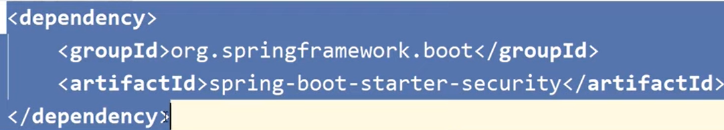
4. 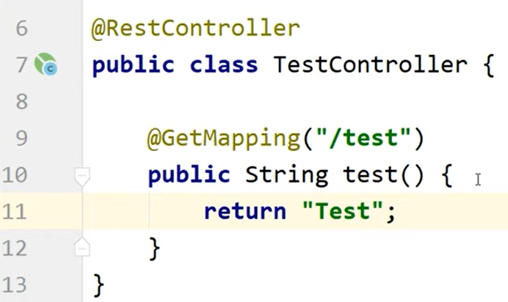
5. 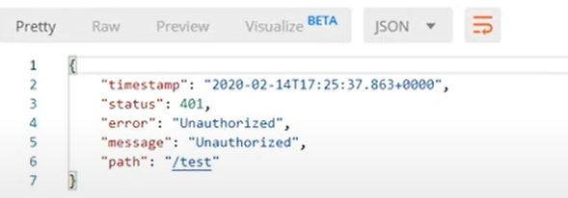
6.   
   UUID
7. 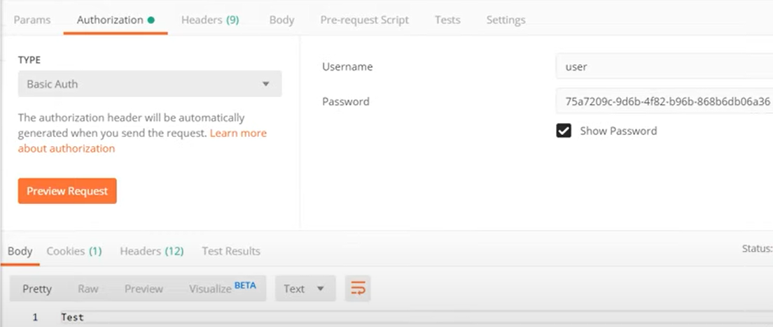
8. 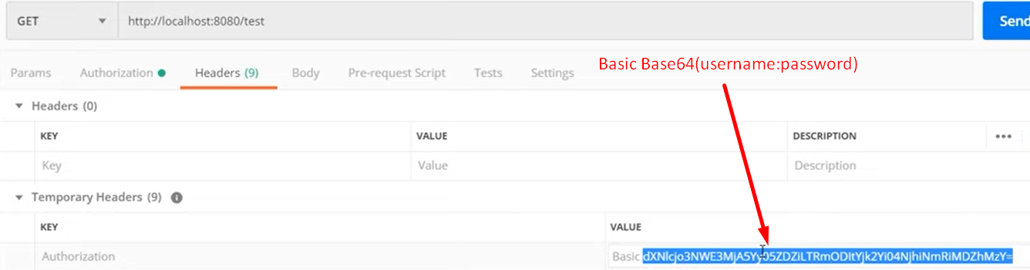
9. 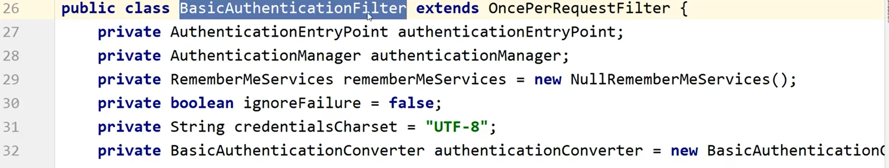
10. 